Programming in Java(BMIS108)

Project Report

Quiz Application

BSc in Computer Science(UCD) Degree 16.2

Group Members:

Pamodi Rathnayake BSC-UCD-CSC-16.2-

Helitha Thalagalaarachchi BSC-UCD-CSC-16.2-

S.Y Kasun Ishanka BSC-UCD-CSC16.2-021

Content

* Overview of the system

1. Introduction
2. Drawbacks
3. Scope

* Functionalities
* Admin

1. Add a Quiz
2. Upload Notes

* User

1. Create an Account
2. Login
3. User Challenge
4. User Learn

**Introduction**

The software**Quiz application**manages the activity of quiz conduction in a school or college or any institution or even as the first test for the recruiters. The system is user friendly and the user will find it easy to answer the question. The Admin/employee will not find any difficult in calculating the total marks scored by the student. The system will thus reduce paperwork and all the information will be stored safely in the database.

The **Quiz application** is used for conducting quiz for school or college students or this software can also be used by the company for the recruitment process. At first, the student is needed to register his/her name along with all the information needed and need to select username and password for the login process. Using this username and password, the student can login into the **“QUIZ”** software.  Next procedure is answering the quiz. As soon as the student selects the quiz menu strip, the questions with 4 options will be displayed. The student has to type any one option and click on next option. ON this click next set of question and answers will be displayed. This will continue till the end of the question.

The admin has the authority to add or modify any questions or options. The answers of each question will be saved in the database.After the quiz marks will be displayed for the Students.

Drawbacks

Scope

**Quality**

* We completed the assignment with all the required functionalites such as Signup/login,Add quiz,Answer quiz,
* We used all the OOP Concepts such as
* **Encapsulaion**
* **Abstract**
* **Inheritance**
* **Polymophism**
* We also embed other concepts such as:
* **JDBC**
* **Threads**
* **Error Handling**
* **GUI**
* **File Handling**

**Functionalities**

* Admin

**Add a Quiz**

Admin is the Controller of this Programme.Admin has permission to Change inside of database and Add questions to this programme.There is a GUI interface as “Admin Quiz”.Admin can log in to the System and run the programme.There is a Admin home.After entered admin in to admin home will be display two options as Upload notes and Add a quiz.Admin can add a quiz for user by clicking on the Add quiz button.

**Upload Notes**

There is another option to an admin named as “Upload Notes”.The Admin can Upload academic learning notes and It will be displayed on User Accounts

* User

**Create an Account and Login**

The student who is willing to learn with this programme , can register his name, college, contact, email id and also should select a password of his own. As soon as registration is complete, that particular student can login with his name and password he chose as input.

**User Challenge**

Our students can log into this database by using the administrator rights.

By answering the given questions student can improve their knowledge.

**User Learn**

When the user upload academic notes , students can refer those stuffs.

UML Diagram

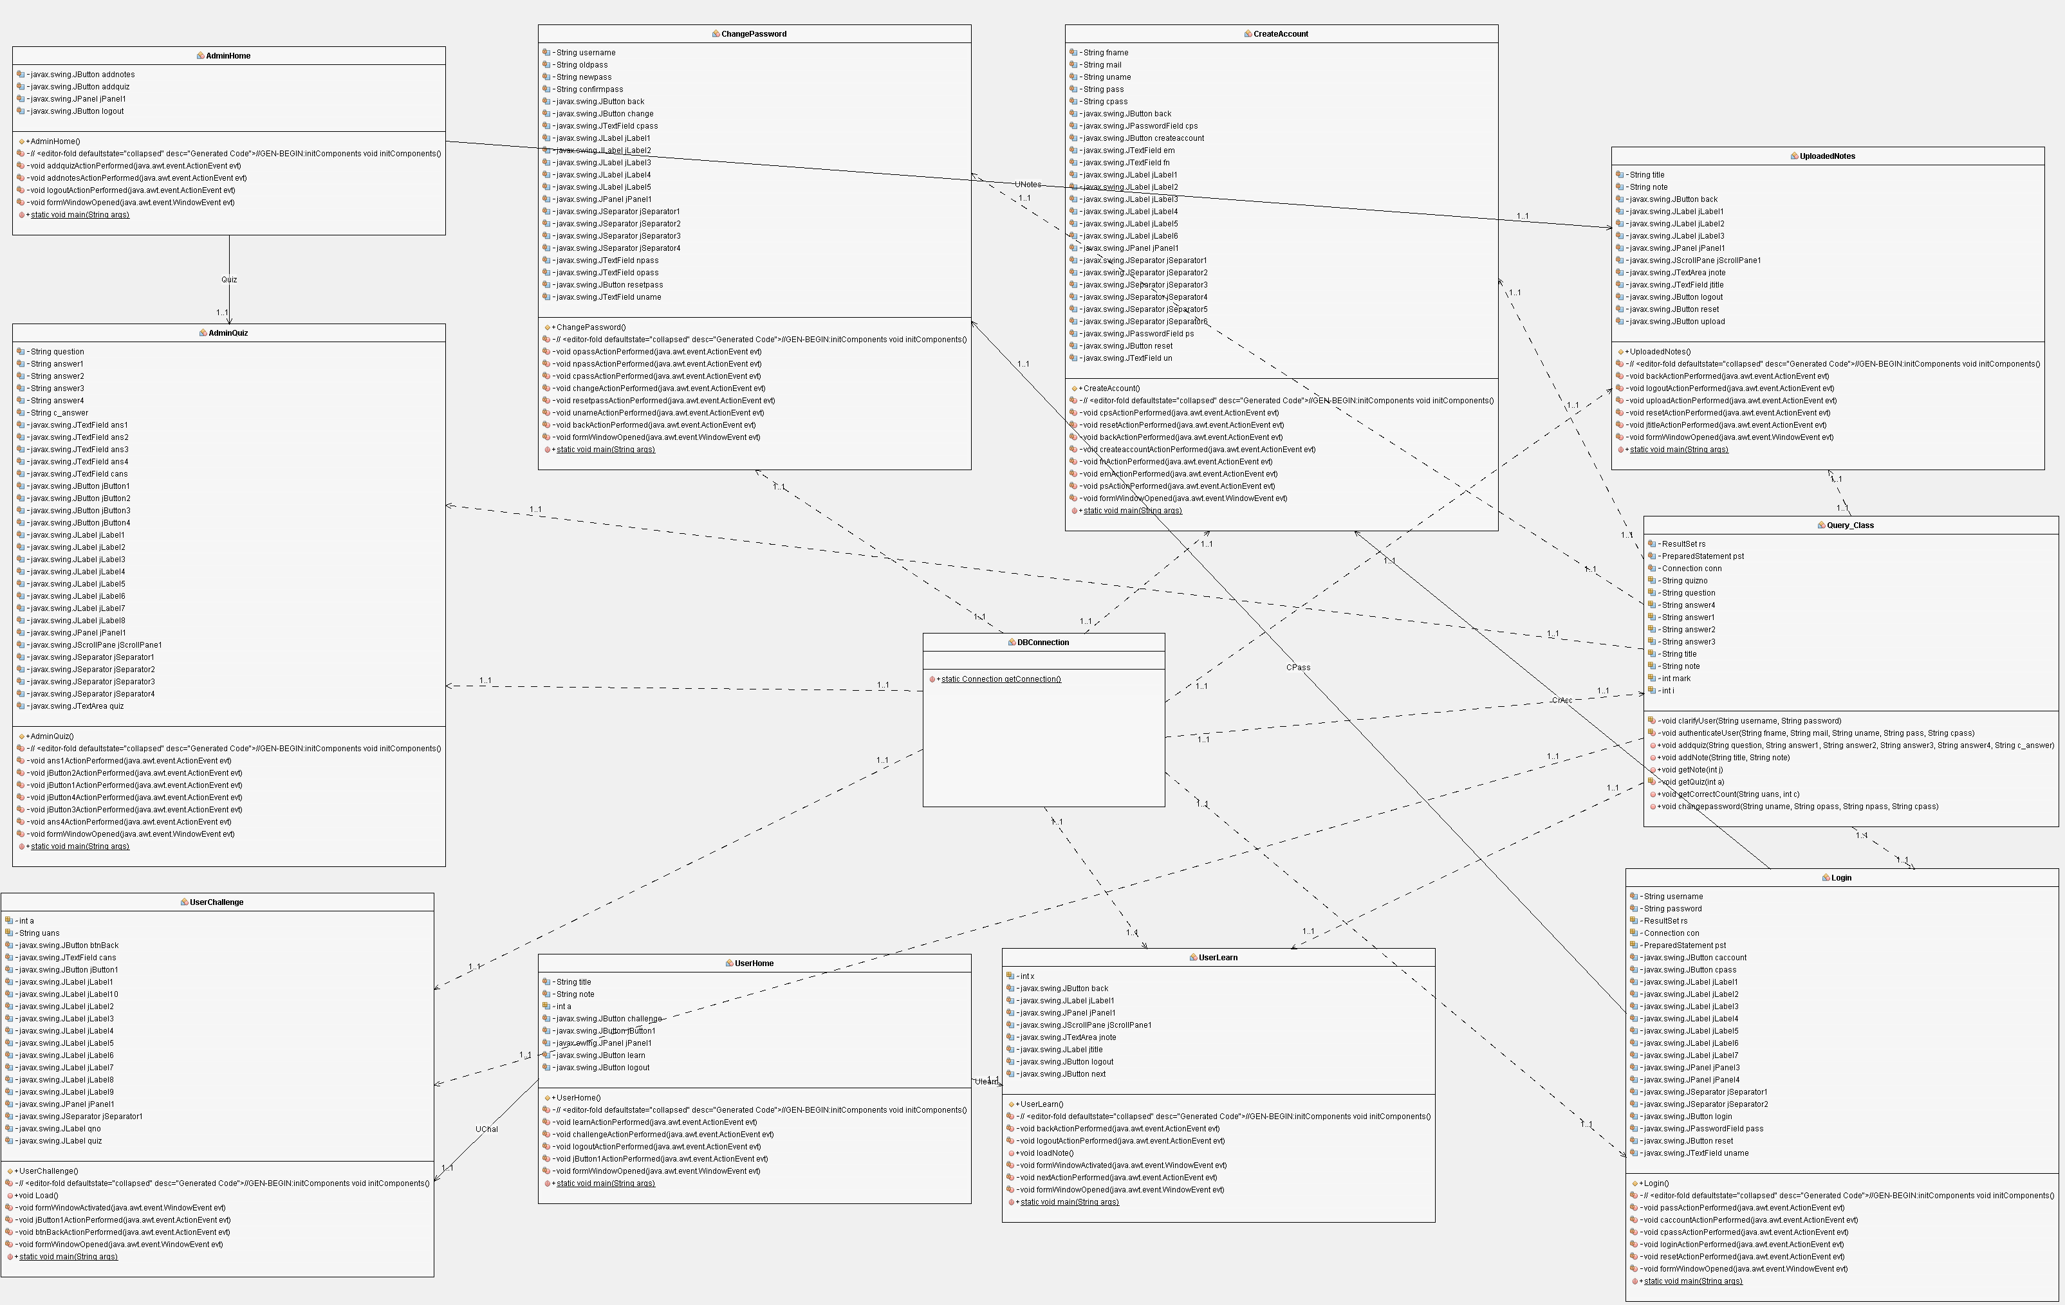

**Experience**

This was a collective effort from group members succeeding all the problems and challenges.While developing this application we learnt lots of things related to a Quiz Application.We carefully used our theory knowledge to develop this Aplication and understood how to design a user friendly application.Finally,we understood how important to maintain errors.

**References:**

Youtube.com

Stackoverflow.com

Tutorialspoint.com